Module 2 Short Paper

Ryan Manchanthasouk

Southern New Hampshire University

January 17th, 2019

Short Answer

Overall, pseudocode was much easier to do as I just had to go through generic steps on how to complete the job. Obstacles that I went through while producing the flowchart were deciphering the operations and connecting the right tasks with the correct shapes. I had a slight difficulty in putting my thoughts in to words with pseudocode.

Flowchart and pseudocode are both major influences on programs or programming processes; both conduct as initial blue prints or guides for the overall program. If either were to not be used, it would be like a traveler finding their way around a city without a map. In other words, creating the program would be hard to follow and unorganized.

Receipt Flowchart

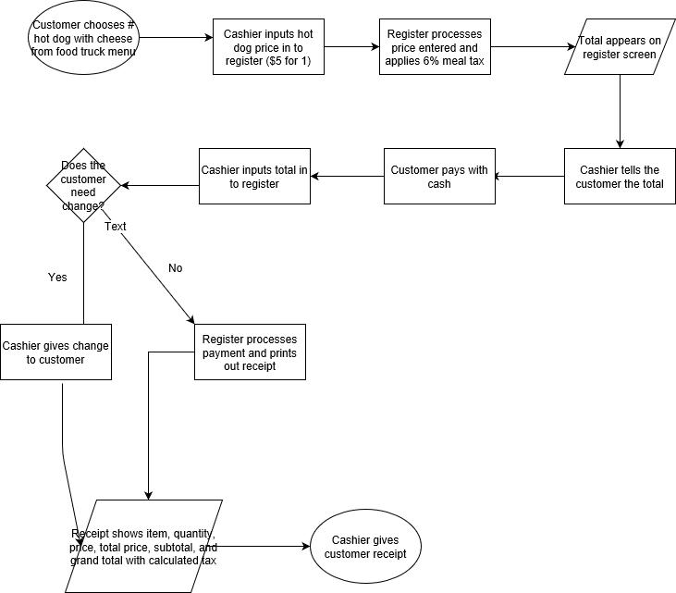

Pseudocode

function DetermineWallSize():

GET measuring tape

MEASURE wall height

MEASURE wall width

GET calculator

CALCULATE height x width to determine area of wall

WALL size is 100 sq. ft.

function DeterminePaintNeeded():

GET paint

READ paint label to determine how much square feet  
 one gallon of paint cancover

EACH gallon of paint covers 10 sq. ft.

function PrintInformation():

CALCULATE how many gallons of paint you need for a 100 sq. ft. wall

10 GALONS of paint will paint a 100 sq. ft. wall

PURCHASE paint

PAINT wall